Problem Statement
Environmental agencies collect air-quality or water-quality readings from many monitoring stations (for example PM2.5 values or pollutant levels). The readings are stored as nested lists, where each station has its own list of measurements. Checking them by hand is slow, and bad values (sensor errors, negative numbers) can spoil the results.
Objectives
- Store station readings in a nested list.
- Clean the data by ignoring invalid readings.
- Calculate average, minimum and maximum for each station.
- Classify each reading and each station’s average using thresholds.
- Display a clear report for every station.
Assumptions
- Each station is stored as [station_name, [reading1, reading2, ...]].
- A valid reading is a number that is zero or greater. Text and negative values are treated as sensor errors and skipped.
- Thresholds are supplied as a list of (upper_limit, label) pairs, in increasing order.
- A reading belongs to the first category whose limit it does not exceed. With the limits used here, 50 is Good and 51 is Moderate.
- The threshold values used (50, 100, 150) are example values, and you can change them for any pollutant.
- A station with no valid readings is reported as “No valid readings”.
Algorithm
- Define the threshold list.
- For each station in the nested list, take its name and readings.
- Clean: keep only numeric readings that are zero or greater, and count how many were skipped.
- If no valid readings remain, report “No data” and move on to the next station.
- Average: sum of valid readings divided by their count.
- Extremes: find the minimum and maximum of the valid readings.
- Classify: compare a value with each threshold limit in order, and return the first label where value <= limit.
- Classify every reading and also the station
Pseudocode
thresholds = [(50,"Good"), (100,"Moderate"), (150,"Unhealthy"), (infinity,"Hazardous")]

FUNCTION clean_readings(readings):
valid = empty list
FOR each r in readings:
IF r is a number AND r >= 0:
add r to valid
RETURN valid

FUNCTION calculate_average(values):
IF values is empty: RETURN None
RETURN sum(values) / count(values)

FUNCTION find_extremes(values):
IF values is empty: RETURN None, None
RETURN min(values), max(values)

FUNCTION classify(value, thresholds):
FOR each (limit, label) in thresholds:
IF value <= limit: RETURN label

FUNCTION analyze_station(name, readings):
valid = clean_readings(readings)
average = calculate_average(valid)
low, high = find_extremes(valid)
labels = classify each value in valid
RETURN results

MAIN:
FOR each [name, readings] in data:
results = analyze_station(name, readings)
print results
Test Cases
# | Test | Input | Expected result
1 | Average | [10, 20, 30] | 20.0
2 | Empty list average | [] | None
3 | Extremes | [5, 1, 9] | (1, 9)
4 | Empty list extremes | [] | (None, None)
5 | Boundary: 50 | classify(50) | Good
6 | Boundary: 51 | classify(51) | Moderate
7 | Boundary: 150 | classify(150) | Unhealthy
8 | Very high value | classify(500) | Hazardous
9 | Cleaning | [10, "x", -3, 0, 7.5] | [10, 0, 7.5]
10 | Station with bad data | [20, "error", -5, 30] | 2 valid, 2 skipped, average 25.0
11 | Station with no readings | [] | “No valid readings”

Output

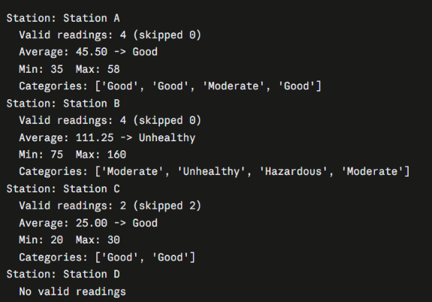
Flowchart
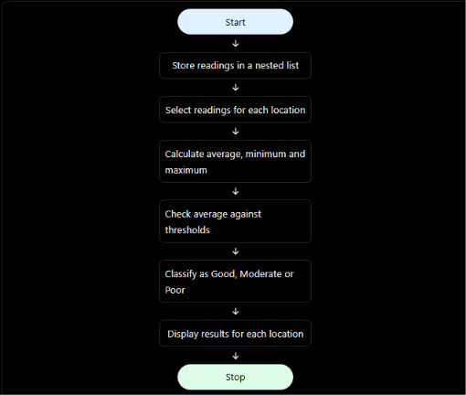

Conclusion
The program analyses nested-list readings for several stations. It cleans invalid data, calculates averages and extremes, and classifies each reading and each station’s average against the supplied thresholds. Because the thresholds are passed in as data, the same code works for air quality, water quality or any other measurement, and you only need to change the threshold list.

